# Introduction

As part of the SBS R2 project, a standardized look-and-feel is being applied to all customer proposals across all service lines. A customer proposal incorporates several different types of documents. This summary guide defines the styles for the documents that make up a proposal.

# Components of a Customer Proposal

|  |  |  |  |
| --- | --- | --- | --- |
| **Cover page** | **Price page** | **Well overview** | **Etcetera** |
|  |  |  |  |

This summary guide describes the styles as used in three document types: the cover page, the price page, and the well overview. The same styles will be applied to all other documents in the proposal.

Cover page

The cover page is consistent across all service lines, with the latest Sanjel branding. The page includes a high-level description of the job as well as contact information for the customer and for key Sanjel personnel.

Price page

The format of the price page depends on the pricing model being used for the quotation: Book Less Discount (BLD) or As Per Bid (APB).

On a BLD price page, each line item includes the product code and description, the unit of measure, the unit price and the discount applied. The line items are grouped in four categories: Services, Materials, Travel/Cartage, and Miscellaneous.

On an APB price page, two or more items can be grouped together as a summary item with a single price. There are two possible formats for APB groups.

* Detailed APB group: Each item in the group is listed, but only the total price for the group is displayed.
* Summary APB group: Individual items are not listed; there is one summary description for the group.

An APB price page may also include BLD elements.

All price pages include a section for additional notes or items, as well as a standard footer that refers to the Terms and Conditions of the proposal.

Well overview

The well overview is a summary of the job design that includes the key information required for executing the job, such as objectives, formation data, implementation notes, and fluids required.

The content and layout of the overview pages depends on the service line. However, the styles are consistent across service lines, as detailed in the following sections of this document.

# Cover Page

The cover page is created as a PDF form. The footer, the vertical header, and the watermark are part of the background, as supplied by Marketing and Communications.

**High profile indicator**

Color: burgundy

Size: 12

Style: bold

Effect: all caps

**Arial** is the font for all text.

The burgundy color is **R: 134, G: 0, B: 56.**

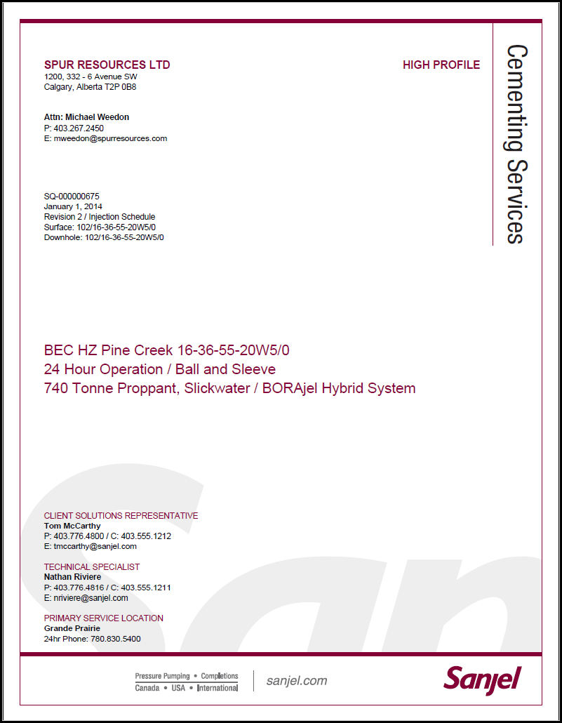

**Contact information**

Color: black

Size: 9

**Technical specialist**

Color: black

Size: 9

Style: bold

**Primary service location**

Color: black

Size: 9

Style: bold

**Client solutions representative**

Color: black

Size: 9

Style: bold

**Titles**

Color: burgundy

Size: 9

Effect: all caps

**Customer contact information**

Color: black

Size: 9

**Job design reference**

Color: black

Size: 9

**Customer name**

Color: burgundy

Size: 12

Style: bold

Effect: all caps

**Well name and location**

**Operation / Technology**

**Job type**

Color: burgundy

Size: 16

**Customer address**

Color: black

Size: 9

**Customer contact**

Color: black

Size: 9

Style: bold

# Price Page – Book Less Discount

The Sanjel logo is in the top left of all price pages.

**Arial** is the font for all text.

**Client company name**

**Well name and location**

Color: black

Size: 11

The burgundy color is **R: 134, G: 0, B: 56.**

**Logo**

8 pt. space below

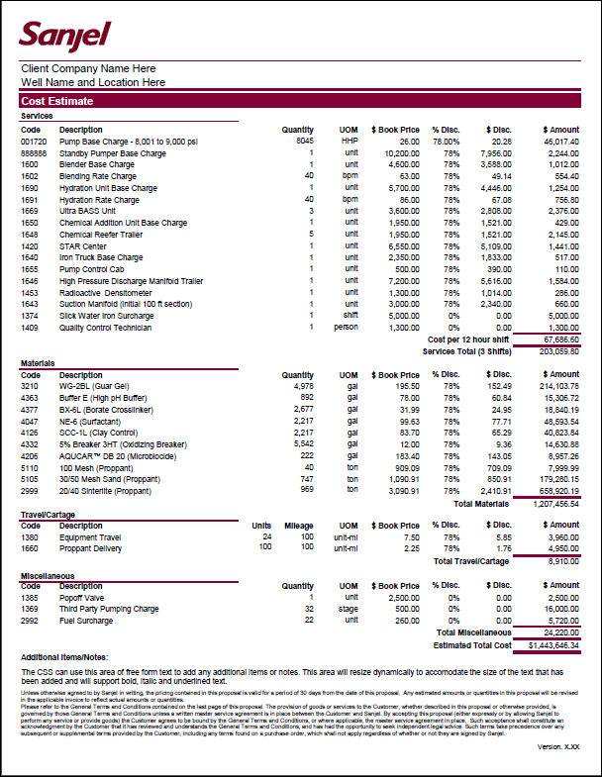

**Section title**

Color: black

Size: 8

Style: bold,

Border: burgundy

**Section total border**

Color: burgundy

Size: medium

**Additional title**

Color: black

Size: 8

**Code** and **Description**:   
left-aligned.

Other columns: right-aligned.

**Main title**

Color: white

Fill: burgundy

Size: 11

**Final total border**

Color: burgundy

Style: double

**Sub-total border**

Color: burgundy

Size: thin

**Total description**

Color: black

Size: 8

Style: bold

**Line item**

Color: black

Size: 8

**Version number**

Color: black

Size: 8

**Column heading**

Color: black

Size: 8

Style: bold

**Terms**

Color: black

Size: 6

**CSS notes**

Color: black

Size: 8

# Price Page – As Per Bid with Detail

The Sanjel logo is in the top left of all price pages.

**Arial** is the font for all text.

**Client company name**

**Well name and location**

Color: black

Size: 11

The burgundy color is **R: 134, G: 0, B: 56.**

**Logo**

8 pt. space below

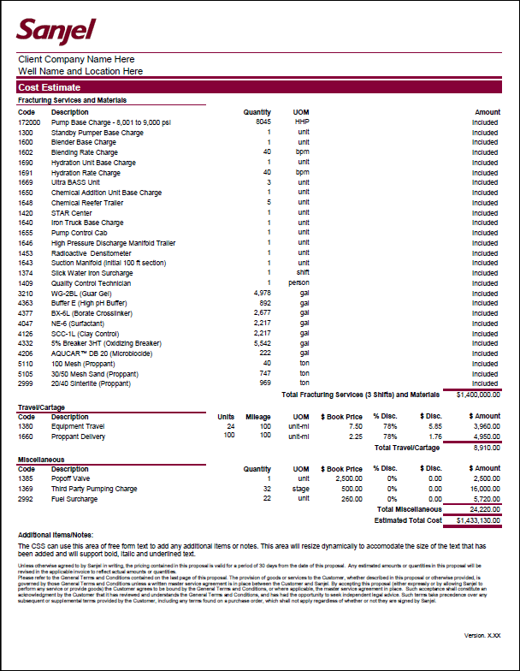

**Section total border**

Color: burgundy

Size: medium

**Section title**

Color: black

Size: 8

Style: bold

Border: burgundy

**Code** and **Description**:   
left-aligned.

Other columns: right-aligned.

**Summary title**

Color: black

Size: 8

Style: bold

Border: burgundy

**Sub-total border**

Color: burgundy

Size: thin

**Final total border**

Color: burgundy

Style: double

**CSS notes**

Color: black

Size: 8

**Total description**

Color: black

Size: 8

Style: bold

**Version number**

Color: black

Size: 8

**Terms**

Color: black

Size: 6

**Additional title**

Color: black

Size: 8

**Column heading**

Color: black

Size: 8

Style: bold

**Main title**

Color: white

Fill: burgundy

Size: 11

# Price Page – As Per Bid with Summary

The Sanjel logo is in the top left of all price pages.

**Arial** is the font for all text.

**Client company name**

**Well name and location**

Color: black

Size: 11

The burgundy color is **R: 134, G: 0, B: 56.**

**Logo**

8 pt. space below

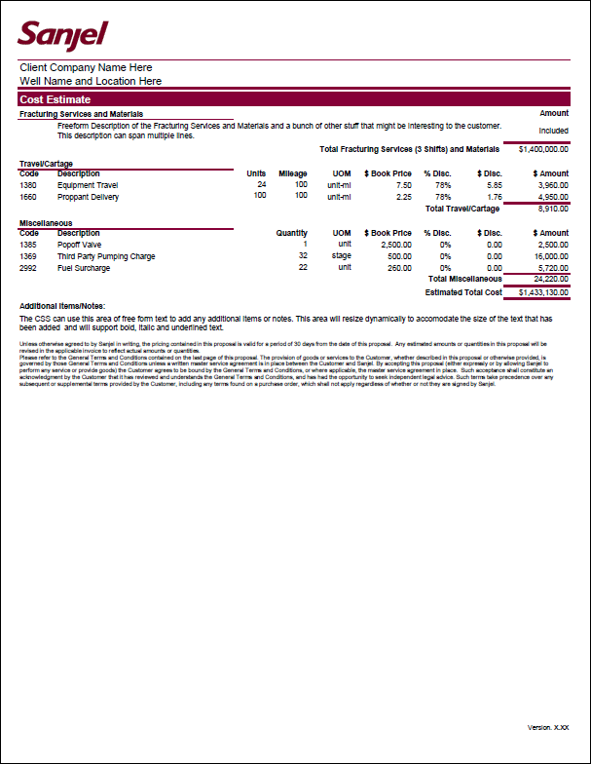

**Section title**

Color: black

Size: 8

Style: bold

Border: burgundy

**Summary title**

Color: black

Size: 8

Style: bold

Border: burgundy

**Code** and **Description**:   
left-aligned.

Other columns: right-aligned.

**Terms**

Color: black

Size: 6

**CSS notes**

Color: black

Size: 8

**Version number**

Color: black

Size: 8

**Additional title**

Color: black

Size: 8

**Column heading**

Color: black

Size: 8

Style: bold

**Section total border**

Color: burgundy

Size: medium

**Sub-total border**

Color: burgundy

Size: thin

**Final total border**

Color: burgundy

Style: double

**Main title**

Color: white

Fill: burgundy

Size: 11

# Well Overview

The exact contents of the overview page are specific to the service line, and the units of measure are specific to the country. An example of a Canadian Cementing overview is shown here, to illustrate the standard styles.

The Sanjel logo is on the top left of all pages. **Arial** is the font for all text except for the bullets. The burgundy color is **R: 134, G: 0, B: 56.**

**Client company name**

**Well name and location**

Color: black

Size: 10

**Program name**

**Well type**

Color: black

Size: 10

Page 1:

**Logo**

8 pt. space below

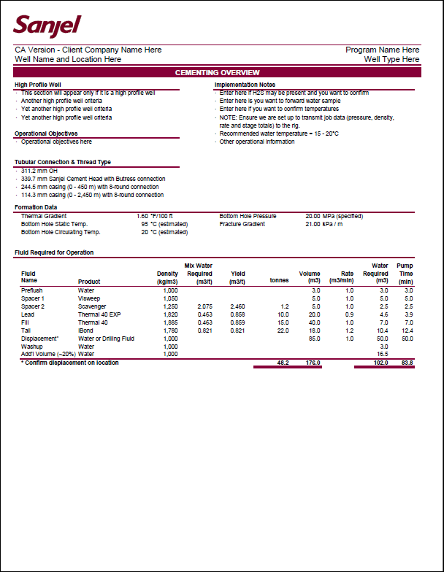

**Total**

Color: black

Size: 8

Style: bold

Border: burgundy, double

**Column heading**

Color: black

Size: 8

Style: bold

Border: burgundy, thin

**Section title**

Color: black

Size: 8

Style: bold

Border: burgundy

**Bullets**

Wingdings 158

Color: black

Size: 8

**Number columns:**

Right-aligned

**Text columns:**

Left-aligned

**Note text**

Color: black

Size: 8

Style: bold

**Body text**

Color: black

Size: 8

**Main title**

Color: white

Fill: burgundy

Size: 10

Centered

Page 2:

Page 2 of the overview does not repeat the main title.

**Program name**

**Well type**

Color: black

Size: 10

**Client company name**

**Well name and location**

Color: black

Size: 10

**Logo**

8 pt. space below

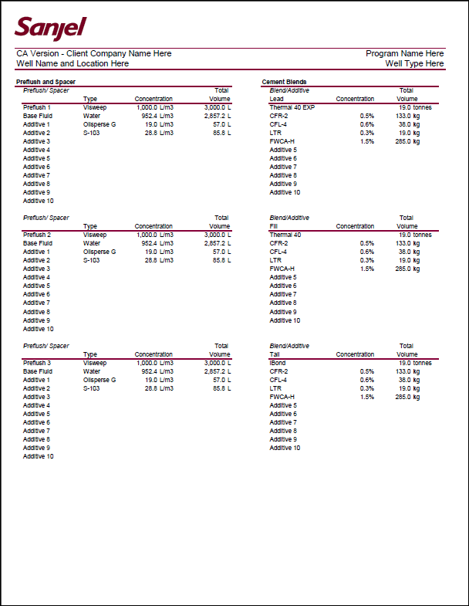

**Body text**

Color: black

Size: 8

**Column heading**

Color: black

Size: 8

Border: burgundy, thin

**Number columns:**

Right-aligned

**Text columns:**

Left-aligned

**Subtitle**

Color: black

Size: 8

Style: italic

**Section title**

Color: black

Size: 8

Style: bold

Border: burgundy, thin